History In Early Years At Sandown
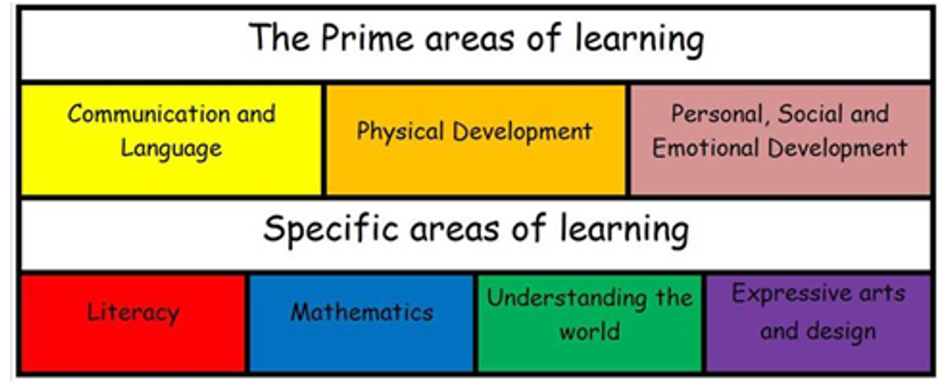

In the Early Years children will explore the past through pictures, books, stories, rhymes and visitors. They will draw on their own experiences and talk about past events in their own lives and those who are important to them.

Children will begin to understand that the past is made up of events that have already happened. They will also begin to compare aspects of their own life now to life in the past.

The ELG (what is expected at the end of Reception) links closely to History is: Past and Present. Before this, children are taught through ‘Understanding the World’.

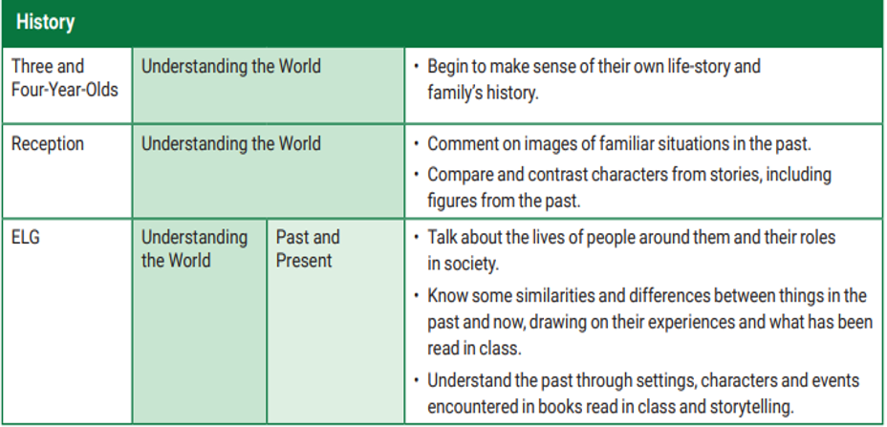

Understanding the world involves guiding children to make sense of their physical world and their community. The frequency and range of children’s personal experiences increases their knowledge and sense of the world around them. At Sandown, we have visits to the local fire station as well as holding our own museum. We meet important members of society such as police officers, paramedics and firefighters. In addition, listening to a broad selection of stories, non-fiction, rhymes and poems will foster their understanding of our culturally, socially, technologically and ecologically diverse world. As well as building important knowledge, this extends their familiarity with words that support understanding across domains. Enriching and widening children’s vocabulary will support later reading comprehension. This vocabulary is also linked to actions through Makaton.
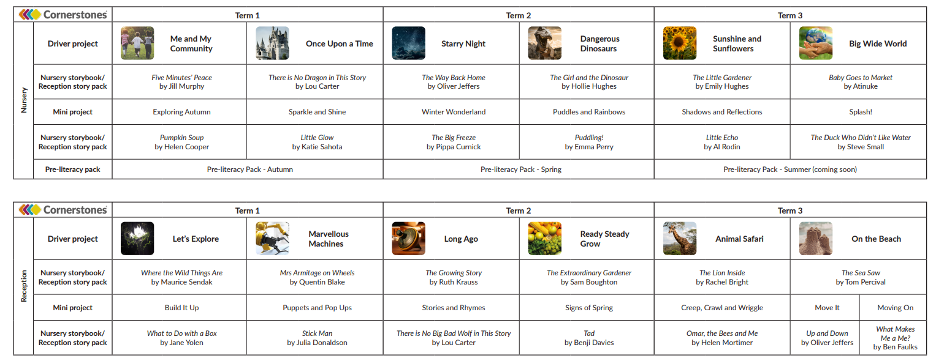
Our Topics link to History:

Reception
History Core Knowledge
Let’s Explore (Term 1)
- Know that some people in history are significant because they did important things.
- Know that the way that people lived in the past is not the same as the way that we live now. E.g. schools, play activities, toys, food, transport, technology and clothes.

Marvellous Machines (Term 2)
- Know that similarities and differences helps us to make comparisons between life now and in the past.
- Know that the way that people lived in the past is not the same as the way that we live now. E.g. schools, play activities, toys, food, transport, technology and clothes.

Long Ago (Term 3)
- Know that the past is made of events that have already happened.
- Know that the way that people lived in the past is not the same as the way that we live now. E.g. schools, play activities, toys, food, transport, technology and clothes.
- Know that similarities and differences helps us to make comparisons between life now and in the past.
- Know that first, then, next, after and last can be used to order information
- Know that words such as yesterday, last week, last year and long ago show the passing of time.
- Know that some people in history are significant because they did important things.

Ready Steady Grow (Term 4)
- Know that first, then, next, after and last can be used to order information
- Know that similarities and differences helps us to make comparisons between life now and in the past.

On the Beach (Term 6)
- Know that words such as yesterday, last week, last year and long ago show the passing of time.
- Know that the way that people lived in the past is not the same as the way that we live now. E.g. schools, play activities, toys, food, transport, technology and clothes.

Evidence:
The learning journey of our EYFS children can be seen through the learning walls, floor books and learning journey books as well as discussions with teachers and pupil voice.
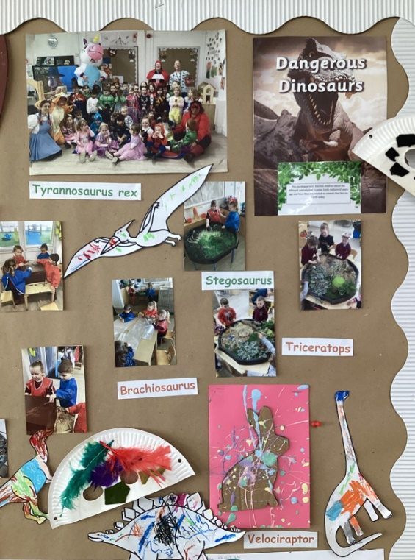
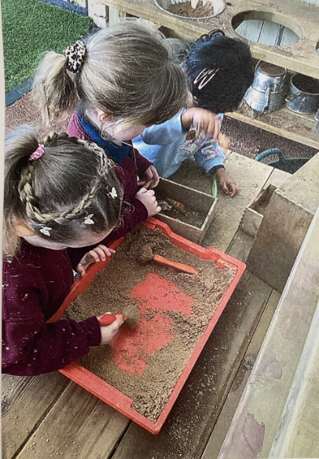
Nursery
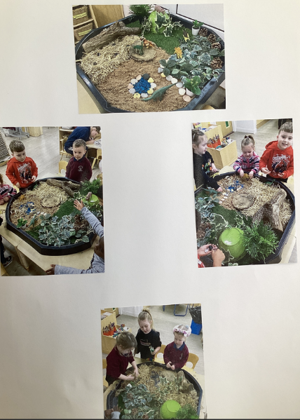

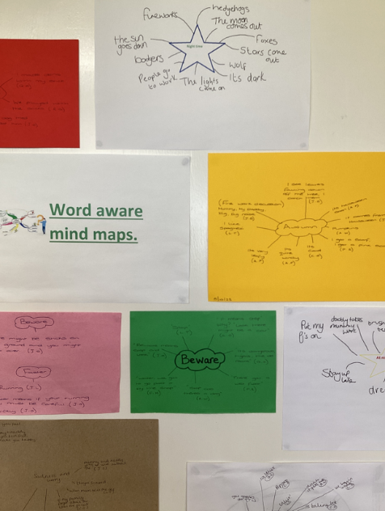
History in EYFS
- Creative displays
- Pupil’s own work
- History through texts
- Adult-led activities
- Continuous and enhanced provision
- Vocabulary
-Child talking confidently about History learning

Ruby in Saplings:
“George fight dragon.”
“George Fighting.”
“Lives in castle.”

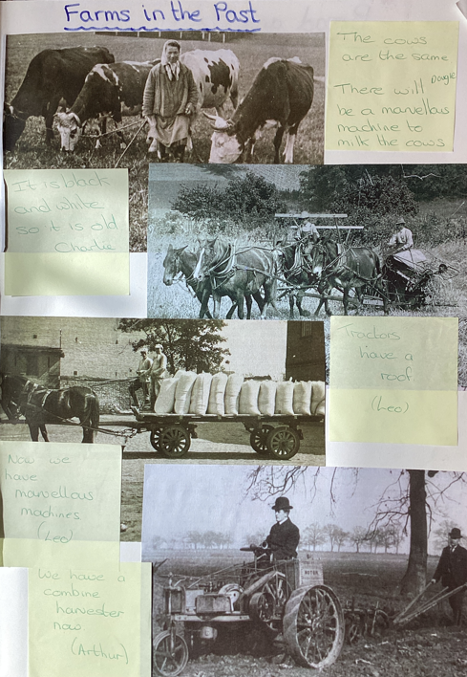
Reception

